RESOLVED: Null pointer exception issue.
Initially set mCurrentAxis and mNewAxis as (Integer) null.
DO NOT DO THAT!!!

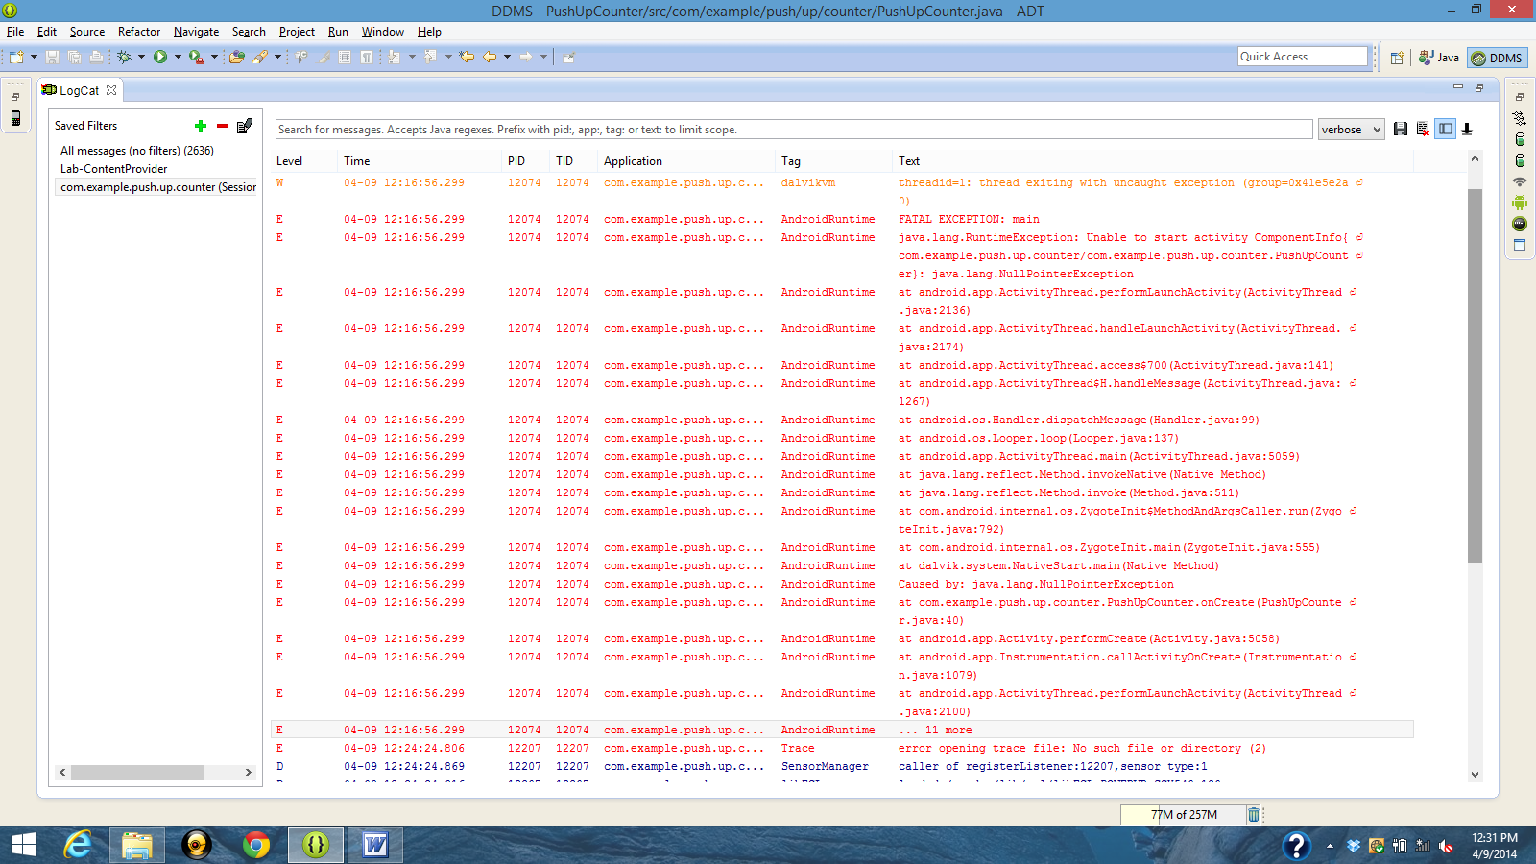

Pushup counter verison 1
Error on launch.
Threading issue.
Boolean pushup evaluator may be an issue.

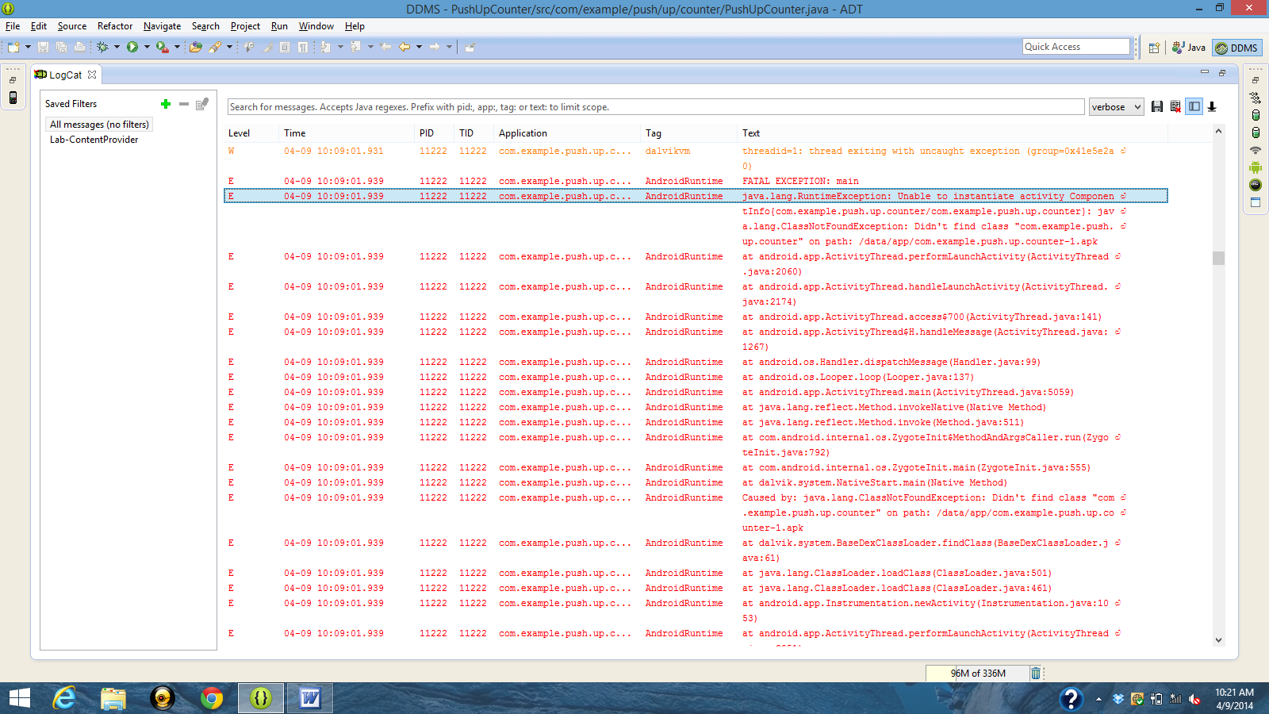

package com.example.push.up.counter;

import android.hardware.Sensor;
import android.hardware.SensorEvent;
import android.hardware.SensorEventListener;
import android.hardware.SensorManager;
import android.os.Bundle;
import android.view.animation.Animation;
import android.view.animation.LinearInterpolator;
import android.view.animation.TranslateAnimation;
import android.widget.TextView;
import android.widget.ViewFlipper;
import android.app.Activity;

public class PushUpCounter extends Activity implements SensorEventListener {

private static final int UPDATE_THRESHOLD = 500;
private SensorManager mSensorManager;
private Sensor mAccelerometer;
private long mLastUpdate;

private ViewFlipper mFlipper;
private TextView mTextView1, mTextView2;
private int mCurrentLayoutState, mCount;

// Axis triggers
private int mCurrentAxis, mNewAxis;

@Override
protected void onCreate(Bundle savedInstanceState) {
super.onCreate(savedInstanceState);

// Initialize values for UI
setContentView(R.layout.main);
mCurrentLayoutState = 0;
mFlipper = (ViewFlipper) findViewById(R.id.view_flipper);
mTextView1 = (TextView) findViewById(R.id.textView1);
mTextView2 = (TextView) findViewById(R.id.textView2);
mTextView1.setText(String.valueOf(mCount));
mCurrentAxis = (Integer) null;
mNewAxis = (Integer) null;

// Get reference to SensorManager
mSensorManager = (SensorManager) getSystemService(SENSOR_SERVICE);

// Get reference to Accelerometer
if (null == (mAccelerometer = mSensorManager
.getDefaultSensor(Sensor.TYPE_ACCELEROMETER)))
finish();

}

@Override
protected void onResume() {
// Register listeners
super.onResume();

mSensorManager.registerListener(this, mAccelerometer,
SensorManager.SENSOR_DELAY_UI);

mLastUpdate = System.currentTimeMillis();
}

@Override
protected void onPause() {
// Unregister listeners
mSensorManager.unregisterListener(this);
super.onPause();
}

@Override
public void onSensorChanged(SensorEvent event) {
// Update Sensor values and increment mCount

if (event.sensor.getType() == Sensor.TYPE_ACCELEROMETER) {

long actualTime = System.currentTimeMillis();

if (actualTime - mLastUpdate > UPDATE_THRESHOLD) {

mLastUpdate = actualTime;

// Implement push-up evaluator method
// Switch UI only when true push-up

if (isPushUpRep(event)) {
mCurrentLayoutState = mCurrentLayoutState == 0 ? 1 : 0;
switchLayoutStateTo(mCurrentLayoutState);
}
}
}
}

@Override
public void onAccuracyChanged(Sensor sensor, int accuracy) {
// No need to change this method
}

public boolean isPushUpRep(SensorEvent event) {
// Boolean evaluator if a true rep is reached
// For loop for index of max value
// Find max value from absolute value(events) list (retrieve index)
// Max value determines what axis gravity is on
// current axis vs. new axis
// conditional if statement
// if current = x and new axis = y then true
// otherwise set new axis to current axis and return false
// If Index == 0, gravity on X axis
// If Index == 1, gravity on Y axis
// If Index == 2, gravity on z axis

float maxValue = 0;
int maxIndex = (Integer) null;
for (int i = 0; i < 3; i++) {
float eventValue = Math.abs(event.values[i]);
if (eventValue > maxValue) {
maxIndex = i;
maxValue = eventValue;
}
}

mNewAxis = maxIndex;

// True push-up = X axis >> Y axis movement
if (mCurrentAxis == 0 && mNewAxis == 1) {
return true;
} else {
mCurrentAxis = mNewAxis;
return false;
}
}

// Animation Methods

public void switchLayoutStateTo(int switchTo) {
mCurrentLayoutState = switchTo;

mFlipper.setInAnimation(inFromRightAnimation());
mFlipper.setOutAnimation(outToLeftAnimation());

mCount++;

if (switchTo == 0) {
mTextView1.setText(String.valueOf(mCount));
} else {
mTextView2.setText(String.valueOf(mCount));
}

mFlipper.showPrevious();
}

private Animation inFromRightAnimation() {
Animation inFromRight = new TranslateAnimation(
Animation.RELATIVE_TO_PARENT, +1.0f,
Animation.RELATIVE_TO_PARENT, 0.0f,
Animation.RELATIVE_TO_PARENT, 0.0f,
Animation.RELATIVE_TO_PARENT, 0.0f);
inFromRight.setDuration(500);
inFromRight.setInterpolator(new LinearInterpolator());
return inFromRight;
}

private Animation outToLeftAnimation() {
Animation outtoLeft = new TranslateAnimation(
Animation.RELATIVE_TO_PARENT, 0.0f,
Animation.RELATIVE_TO_PARENT, -1.0f,
Animation.RELATIVE_TO_PARENT, 0.0f,
Animation.RELATIVE_TO_PARENT, 0.0f);
outtoLeft.setDuration(500);
outtoLeft.setInterpolator(new LinearInterpolator());
return outtoLeft;
}
}

